Poultry Science, BS, 2017
[If applicable, describe the academic degree program options (e.g., formal options/tracks) represented in this report as well as distance options.]

[Optional – Describe background information on the academic degree program (e.g., program mission, program history, mention of disciplinary accreditation requirements, number of students).]

The undergraduate B.S. in Poultry Science consists of two options: poultry science production and pre- veterinary science. The poultry science B.S. degree is designed to prepare students for careers in the poultry industry, admission into poultry science graduate programs, or admission into professional schools (e.g., College of Veterinary Medicine). During the 2016-17 academic year, approximately 60 undergraduate students were enrolled in the poultry science program. This report combines data for all students majoring in poultry science.

Student Learning Outcomes

Specificity of Outcomes

SLO 1: Production - Students will be able to describe and explain the different husbandry practices involved in the various integrated commercial poultry production systems used in producing meat and eggs for different markets around the world.

SLO 2: Embryonic Development - Students will be able to explain poultry fertility concepts and embryonic development within the egg.

SLO 3: Anatomy/Physiology - Students will be able to describe the anatomy and physiology of poultry.

SLO 4: Poultry Nutrition - Students will be able to explain the role of proper nutrition on poultry growth efficiency, including the functions and deficiency signs of amino acids, minerals, and vitamins.

SLO 5: Poultry Health - Students will recognize health issues associated with poultry production, including the prevention of diseases and how to counteract diseases if they do occur.

SLO 6: Processing - Students will be able to describe how live poultry is processed into food products.

SLO 7: Food Safety - Students will gain knowledge in the food safety principles and regulations of the United States food industry, and be able to design a hazard analysis and critical control point (HACCP) plan that could be implemented in a food plant.

SLO 8: Communication - Students will demonstrate effective oral and written communication skills. SLO 9: Problem Solving - Students will be able to solve poultry science-related questions/problems.
SLO 10: Professionalism - Students will demonstrate the ability to interact and communicate professionally with people in the poultry science industry.

Comprehensive Outcomes

For the B.S. in poultry science, the above outcomes are comprehensive based on the curriculum models and expectations from our industry stakeholders. The Department of Poultry Science recently revised the curricula to include POUL 2100 and POUL 5030. POUL 5140 was replaced by POUL 5110 in the pre-veterinary science option. Based on curricular changes, the current SLO list was modified slightly from that shown in last year’s report.

Communicating Student Learning Outcomes

The outcomes listed above have been distributed to faculty via email and discussed at faculty meetings. The SLO list is being added to the departmental website so students have the opportunity to view them.

Curriculum Map

Curriculum Map

SLOs are assessed in at least one course as indicated by the curriculum map below.

 | POUL  1000 | POUL  2100 | POUL  3030 | POUL  3060 | POUL  3150 | POUL  4920 | POUL  5030 | POUL  5050 | POUL  5080 | POUL  5110 | POUL  5160
SLO 1: Production | 1 | V | 2 | 2 | 1 | V | 2 | 2 | 1 | 1 | 0
SLO 2: Embryonic Development | 1 | V | 1 | 2 | 1 | V | 1 | 0 | 1 | 0 | 0
SLO 3: Anatomy/Physiology | 1 | V | 1 | 2 | 2 | V | 1 | 1 | 1 | 1 | 0
SLO 4: Poultry Nutrition | 1 | V | 1 | 1 | 1 | V | 1 | 2 | 1 | 0 | 0
SLO 5: Poultry Health | 1 | V | 1 | 1 | 1 | V | 1 | 0 | 2 | 0 | 0
SLO 6: Processing | 1 | V | 1 | 0 | 1 | V | 1 | 0 | 1 | 2 | 0
SLO 7: Food Safety | 1 | V | 0 | 1 | 0 | V | 1 | 0 | 1 | 1 | 2
SLO 8: Communication | 1 | 2 | 2 | 1 | 2 | 2 | 2 | 2 | 2 | 2 | 1
SLO 9: Problem Solving | 1 | 1 | 2 | 1 | 2 | 1 | 2 | 2 | 2 | 2 | 1
SLO 10: Professionalism | 1 | 2 | 2 | 1 | 2 | 2 | 2 | 1 | 2 | 2 | 1

0 = no coverage; 1 = some coverage; 2 = extensive coverage; V = variable

Measurement

Outcome-Measure Alignment

Most SLOs are assessed using a combination of a pre-test/post-test, specific exam questions, or class assignments. Several rubrics have been developed to help with assessing class assignments (e.g., written communication, oral communication, projects). Specifically, pre-test/post-test methodology is used for SLOs 1-7. A class project is also used to assess SLO 7, which is quantitated by a rubric. SLO 8 is assessed via written assignments and presentations in class, which are also evaluated using rubrics.
SLO 9 is evaluated using specific exam questions across multiple classes. SLO 10 is assessed using a survey of internship supervisors.

Direct Measures

The tools described in the previous section (pre-test/post-tests, class assignments) are all directly measuring each respective SLO. Thus, each SLO has a direct measurement.

Data Collection

For some SLOs, individual faculty members collect data for their courses, usually in the form of pre- test/post-test results. The pre-test consists of a series of questions administered in class at the beginning of the semester. The same or similar questions are re-administered later in the semester (either as exam questions, an end-of-the-semester post-test, or part of the final exam). Number of correct responses to both the pre-test and post-test on a question by question basis are reviewed by the faculty member and reported to the assessment coordinator.

Communication skills are evaluated using rubrics that assess both written and oral communication skills. The faculty member completes the rubric, which is returned to the student to hopefully improve their future performance. All scores are reported to the assessment coordinator at the end of the semester. Class projects also assess students’ abilities in POUL 5110 and POUL 5160. A rubric is used to help identify areas where students’ performance needs improving. All poultry science students complete an internship in the poultry industry. The on-site supervisor completes a performance evaluation form on the student from which professionalism is evaluated.

Sample rubrics appear below:

Writing Assessment Rubric in POUL 3030

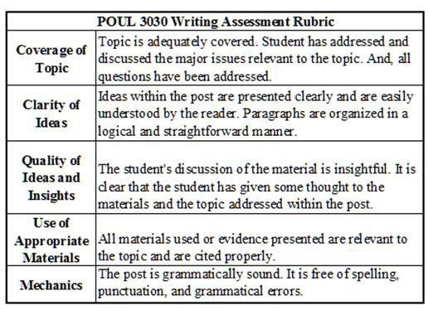

Portions of the Auburn University ePortfolio Rubric (Auburn University ePortfolio Rubric PDF) used in POUL 3160

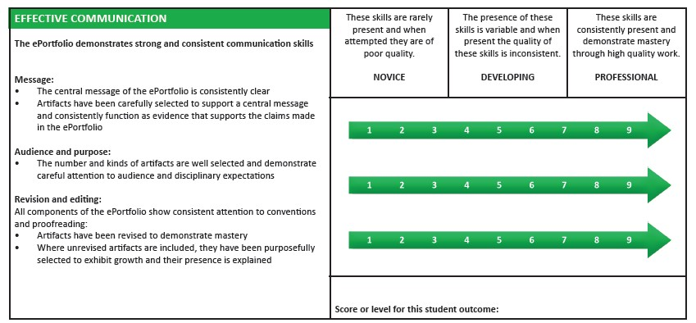
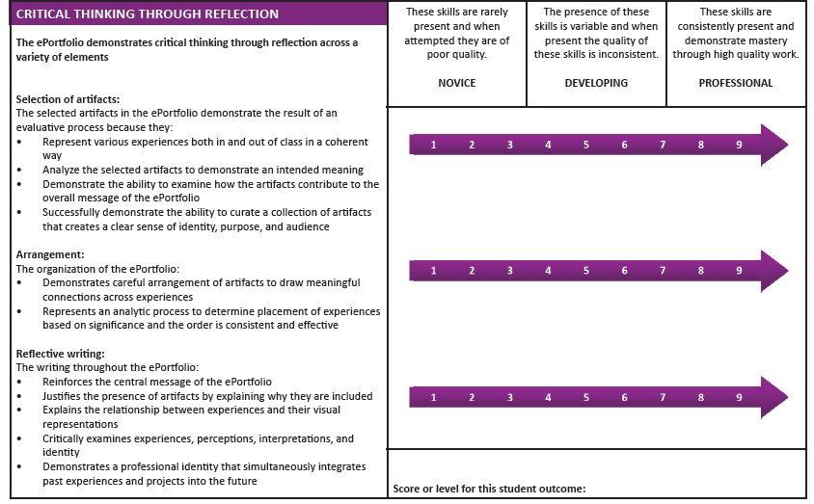

Principles of Food Safety POUL 5160 HACCP Term Paper Rubric

Results

Reporting Results
[Please provide assessment results aligned with the student learning outcomes. If historical assessment data is available, consider providing this data to reveal any student learning trends.]

Interpreting Results
[Please provide an interpretation of the results aligned with the student learning outcomes. The interpretation should reflect consideration of factors (e.g., capabilities of a particular cohort, innovative curricular change) that may have affected the results. ]

Communicating Results
[Please provide a very brief narrative describing with whom the results are shared (e.g., all program faculty).]

Use of Results

Purposeful Reflection and Action Plan
[Please provide a narrative describing the process in which faculty engage to discuss assessment results and create actionable plans in an effort to improve student learning.]

